Source https://www.viator.com/tours/Ubud/Full-Day-Bali-ATV-Ride-and-White-Water-Rafting-with-Lunch-and-Transfers/d5467-7516P44
__________________________________________________________

Bali Ultimate Thrill Combo: ATV Jungle Ride & Ayung River Rafting
__________________________________________________________
★★★★★ 4.7/5 20 reviews

Add to wishlist ♡

__________________________________________________________

8–9 hours | €45 per person

🏕  Image | 🏕  Image | 🏕  Image | 🏕  Image | 🏕  Image | 🏕  Image

__________________________________________________________
About This Tour
Get ready for a full day of adrenaline and adventure in Bali. This action-packed combo experience blends two of the island’s most exciting outdoor activities: white water rafting on the legendary Ayung River and an off-road ATV ride through jungle trails, muddy tracks, and countryside paths.
With professional guides, safety equipment included, and a delicious buffet lunch overlooking lush landscapes, this experience is perfect for thrill-seekers who want to explore Bali beyond the beaches.
__________________________________________________________
What’s Waiting for You
- Duration: 8–9 hours
- Languages Available: English
- Group Size: Up to 39 travelers
- Guide: Professional activity instructors
- Lunch Included: Buffet lunch with jungle views
- Transfers: Optional round-trip hotel pickup available
- Insurance: Included
__________________________________________________________

Check Dates & Availability

Select participants: (Age 99 and younger) - 1 +

Choose date:
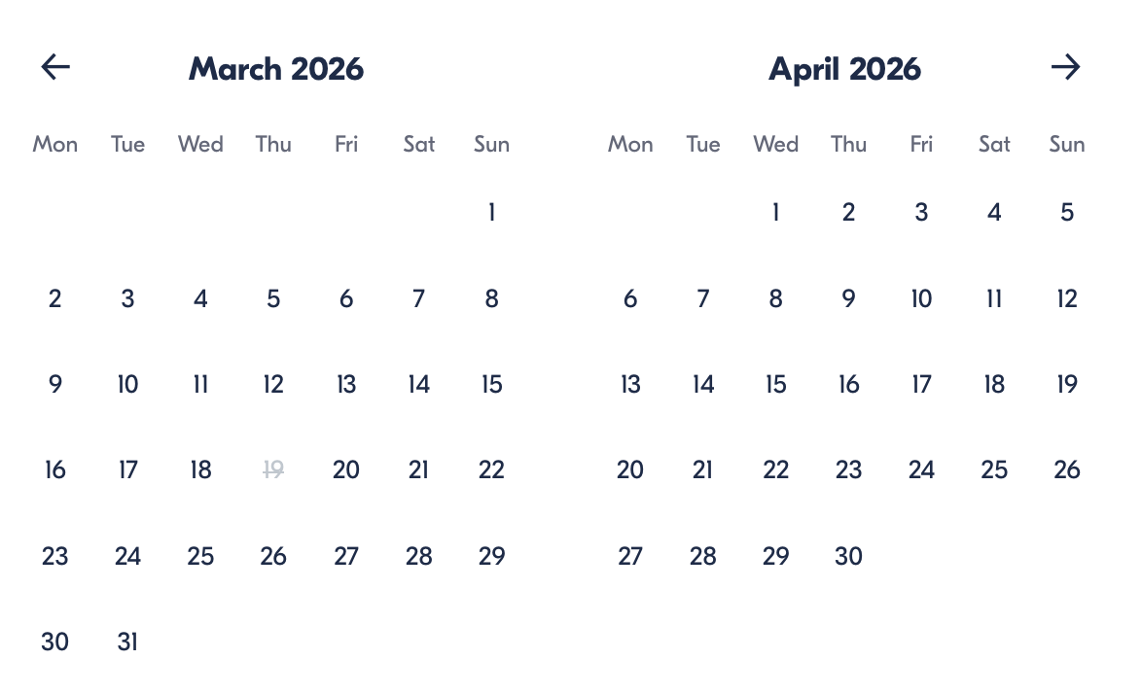

Check Availability

opens:

Participants: 1 March 16, 2026

Bali Ultimate Thrill Combo: ATV Jungle Ride & Ayung River Rafting

- Starting times: 8:30 AM / 9:00 AM

Cancellation:

- More than 24 hours before start — Full refund
- 24 hours or less before start — No refund

Price breakdown: 1 Participant x €45

Total: €45

The total price includes all taxes and fees.

Add to cart Book now

__________________________________________________________
Tour Features
- Ayung River White Water Rafting: Navigate exciting rapids and discover hidden waterfalls
- ATV Jungle Adventure: Ride solo or tandem through muddy trails and riverside terrain
- Buffet Lunch: Enjoy a satisfying meal with stunning jungle views
- Safety First: Helmets, boots, and full safety equipment provided
- Optional Transfers: Door-to-door pickup and drop-off available
- Hot Showers On-Site: Rinse off after your muddy adventure
__________________________________________________________
Detailed Itinerary

White Water Rafting on the Ayung River (≈ 2 hours)
Begin your day with a guided rafting adventure along the Ayung River. Paddle through lush jungle scenery, navigate thrilling rapids, and pass cascading waterfalls hidden deep within the rainforest. Professional guides ensure both safety and excitement throughout the journey.

Buffet Lunch with Jungle Views
After rafting, recharge with a delicious buffet lunch at a local restaurant overlooking Bali’s tropical landscape. Enjoy panoramic jungle scenery while refueling for your next adventure.

ATV Jungle Ride (≈ 1.5 hours)
Gear up with a helmet and boots before heading out on your quad bike. Choose between solo riding (minimum age 12) or tandem (driver + passenger). Navigate muddy tracks, rice fields, riverside paths, and scenic countryside trails for a true off-road thrill.
Once finished, freshen up using the provided shower facilities before heading back to your accommodation (if transfer option selected).
__________________________________________________________
Included in Price
- Professional activity guides
- All safety equipment
- Helmet and boots
- White water rafting experience
- ATV ride experience
- Buffet lunch
- Bottled water
- Insurance
__________________________________________________________
Not Included
- Photos/DVD (available for purchase)
- Gratuities
__________________________________________________________
Pickup Information (Optional Package with Transfers)
Complimentary round-trip transfers are available in:
Seminyak, Kuta, Legian, Canggu, Jimbaran, Nusa Dua, Sanur, Benoa Port, Ubud, Pererenan, Kerobokan, Umalas, Mengwi, Denpasar, Gianyar, Tegallalang, Tanjung Benoa, and surrounding areas.
Drop-off is at the original pickup location.
__________________________________________________________

Who Should Avoid This Tour
- Wheelchair users
- Pregnant travelers
- Travelers with back problems
- Individuals with heart conditions or serious medical issues
__________________________________________________________
Important Trip Info
- Minimum age: 5 years
- Solo ATV riders must be at least 12 years old
- Tandem bookings must be in multiples of 2 participants
- Children aged 5–11 must ride tandem with an adult
- Quad bike ride lasts approx. 1.5 hours
- Rafting lasts approx. 2 hours
- Tour duration approx. 9 hours with transfers
- Most travelers can participate
__________________________________________________________

Cancellation Policy
- More than 24 hours before start — Full refund
- 24 hours or less before start — No refund
__________________________________________________________
What Our Clients Are Saying

Overall rating  4.7/5  ★★★★★  Based on 20 reviews | Review summary  Guide 4.5/5  Transportation 4.6/5  Service 4.7/5  Organisation 4.5/5

Filter  - All traveller types  - Couples  - Group of friends  - Families  By star rating  - All star ratings  - 5 stars  - 4 stars  - 3 stars  - 2 stars  - 1 star | Search reviews (e.g., guide)  Sort by:  - Top picks  - Latest reviews  - Best ratings  - Lowest ratings
__________________________________________________________
★★★★★
Liam R. — Australia
An absolute adrenaline rush! Rafting was incredible and the ATV ride was pure fun. Highly recommend.
★★★★★
Carlos M. — Spain
Perfect mix of adventure and scenery. Everything was well-organized and smooth.
★★★★★
Sophia L. — Singapore
The jungle trails were amazing. The lunch spot had stunning views.
★★★★★
Chen W. — China
Professional guides and great safety standards. Would definitely do it again.
★★★★★
Michael D. — United States
One of the best adventure days I’ve had in Bali!
See more reviews
__________________________________________________________

Meta tags

Page - Bali Ultimate Thrill Combo: ATV Jungle Ride & Ayung River Rafting

Title: Bali Ultimate Thrill Combo: ATV Jungle Ride & Ayung River Rafting | Travellio Global

Description: Experience Bali’s ultimate adventure combo with white water rafting on the Ayung River and an ATV jungle ride. Includes lunch, safety gear, and optional hotel transfers. Book your adrenaline-filled day today.

H1 - Bali Ultimate Thrill Combo: ATV Jungle Ride & Ayung River Rafting
__________________________________________________________

